Secure Secrets, the CLI Way
Student Lab: Azure Key Vault, Blob Storage & a .NET API
All commands use Windows Command Prompt (cmd.exe)

Lab Overview
In this lab you will build a complete, security-first cloud application entirely from the command line. By the end you will have an Azure Key Vault storing a Blob Storage connection string, and an ASP.NET Core Web API that retrieves that secret at startup using a Managed Identity — no passwords, no hard-coded credentials, and no Portal clicking.

What You Will Build
Lab | Goal
Lab 1: CLI Setup | Sign in, set variables, create the resource group
Lab 2: Key Vault | Create an RBAC-enabled vault and test secret read/write
Lab 3: Blob Storage | Create a storage account and store the connection string in Key Vault
Lab 4: .NET API Scaffold | Scaffold an ASP.NET Core Web API and add the Azure packages
Lab 5: Key Vault Integration | Wire Key Vault into the app configuration using DefaultAzureCredential
Lab 6: Blob Endpoints | Build upload and download endpoints that use the Key-Vault-sourced connection string
Lab 7: Deploy with Managed Identity | Deploy the API to App Service and grant it passwordless access to Key Vault
Lab 8: Cleanup | Delete all resources with a single command

Before You Start
- Open a Windows Command Prompt (cmd.exe). Look for plain C:\...> at the prompt — if you see PS C:\...> you are in PowerShell and the variable syntax will be different.
- Confirm the Azure CLI is installed: az --version
- Confirm the .NET SDK is installed: dotnet --version (8.0 or later required)
- You need an active Azure subscription.
Tip
All variables you set with the set command only last for the current session. Keep this cmd.exe window open for the whole lab. If you close it and reopen, you will need to re-run the set commands from Lab 1.
Important
Key Vault names and Storage account names must be globally unique across all of Azure. Use the %RANDOM% trick in Lab 1 to generate a unique suffix — do not change it once you have set it.

Lab 1: CLI Setup

Step 1 — Sign In
- Run the following command. A browser window will open for you to log in.
az login

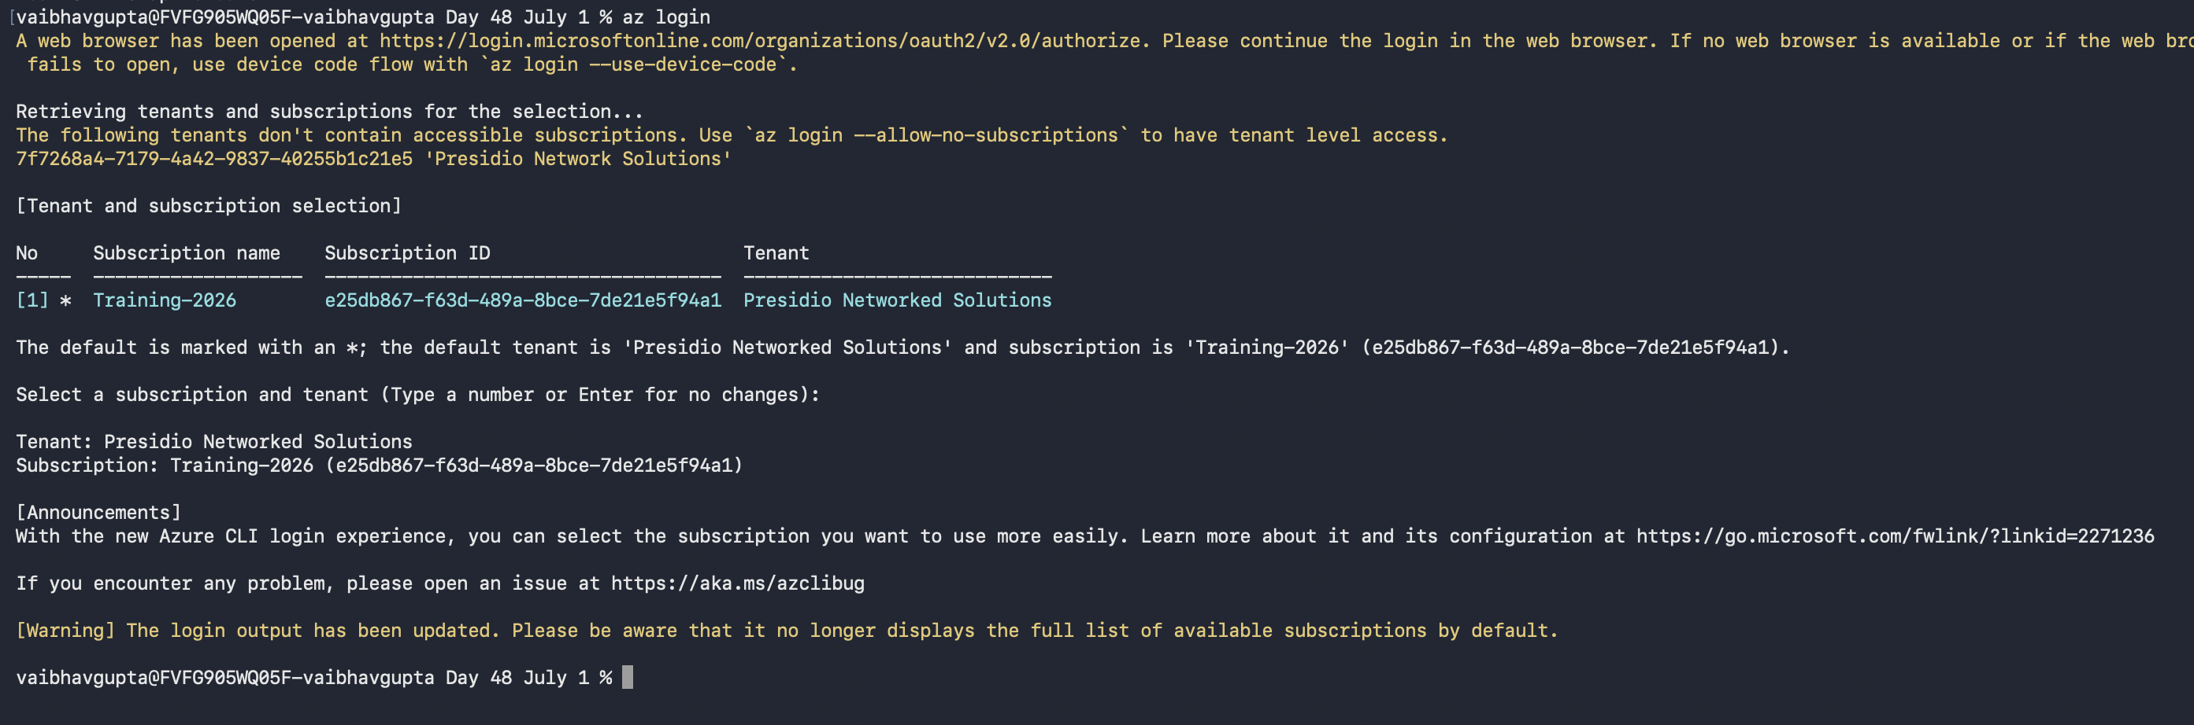

Step 2 — Set Your Variables
- Type each command exactly as shown. Do not add spaces around the = sign.
REM Set reusable variables (cmd.exe)
set RG=cli-lab-rg
set LOCATION=eastus
set /A SUFFIX=%RANDOM%
set KV_NAME=cli-lab-kv-%SUFFIX%
set SA_NAME=clilabsa%SUFFIX%
set CONTAINER_NAME=uploads
- Confirm each variable was set correctly:
echo %RG%
echo %KV_NAME%
echo %SA_NAME%

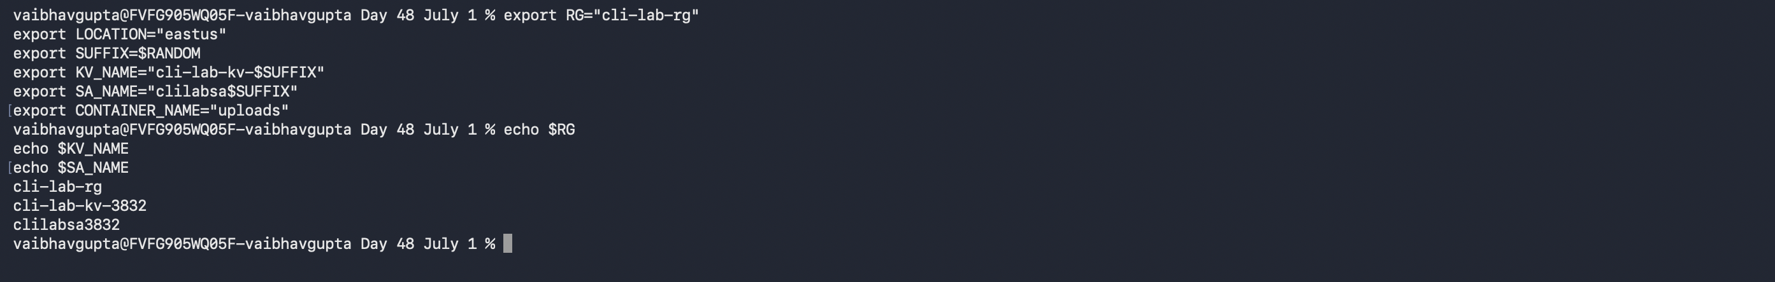

Write your values here for reference during the rest of the lab:
KV_NAME value | cli-lab-kv-3832 ___________________________________________

SA_NAME value | clilabsa3832

SUFFIX value | _______________________________________________

Step 3 — Create the Resource Group
az group create --name %RG% --location %LOCATION%

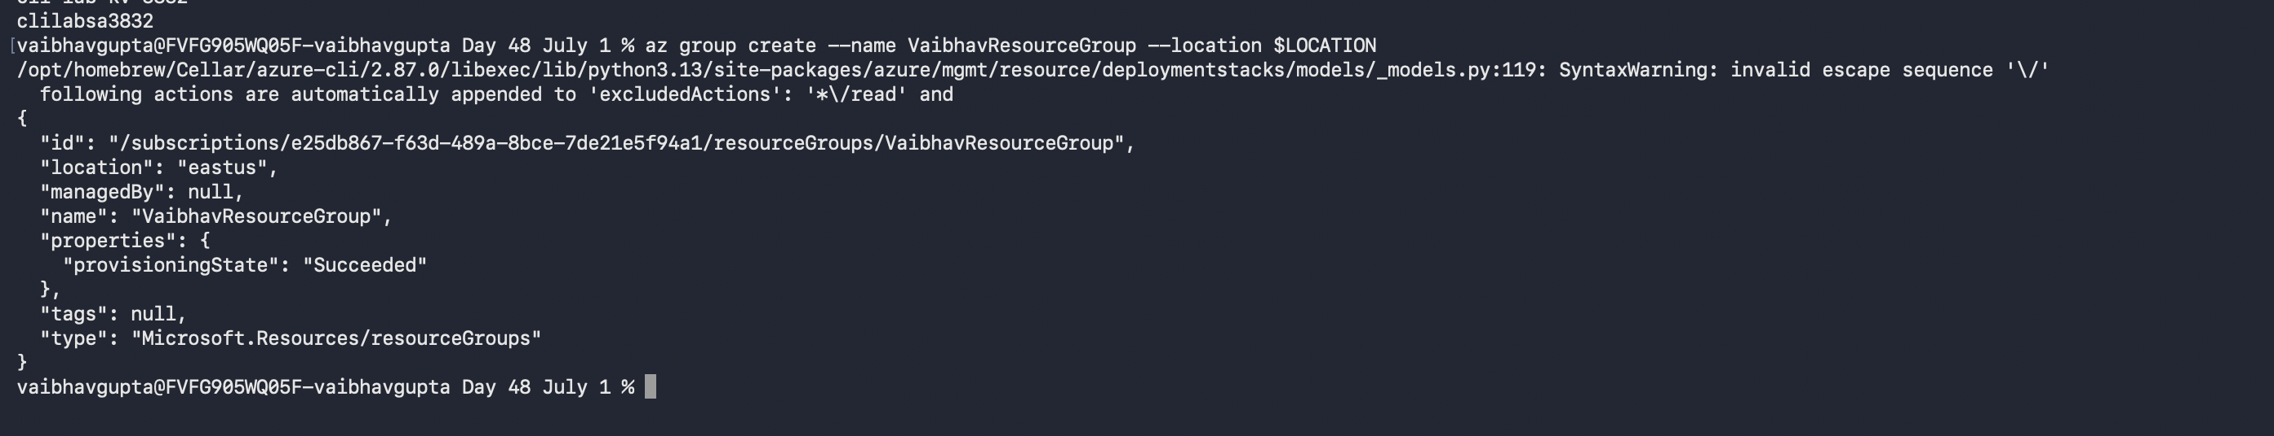

Lab 2: Create and Secure a Key Vault

Step 1 — Create the Vault
- Run the following command. The ^ symbol continues the command on the next line — type it exactly as shown.
az keyvault create ^
--name %KV_NAME% ^
--resource-group %RG% ^
--location %LOCATION% ^
--enable-rbac-authorization true

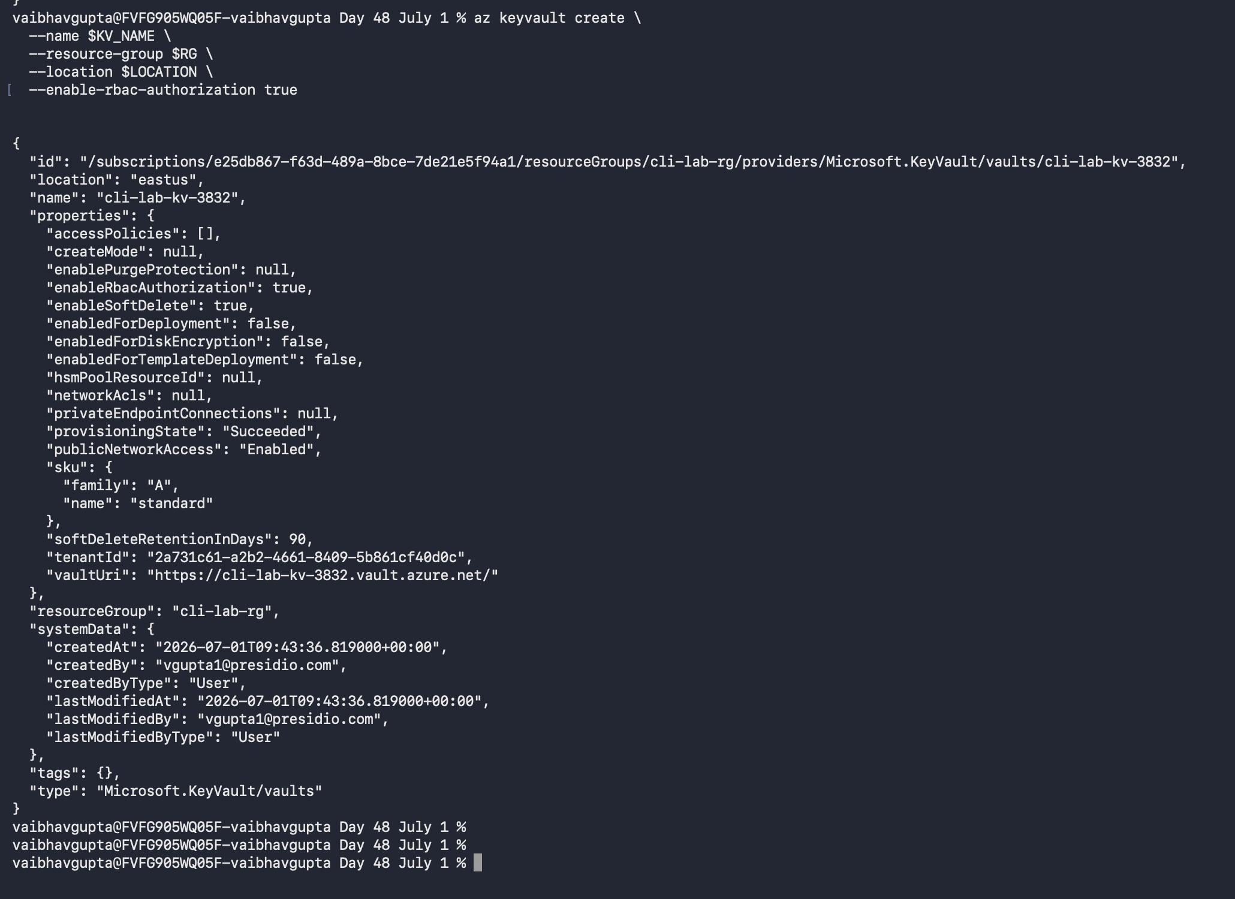

Step 2 — Grant Yourself Access
- Capture your user principal name and subscription ID, then create the role assignment:
for /f "delims=" %a in ('az ad signed-in-user show --query userPrincipalName -o tsv') do set MY_UPN=%a
for /f "delims=" %a in ('az account show --query id -o tsv') do set SUBSCRIPTION_ID=%a

az role assignment create ^
--role "Key Vault Secrets Officer" ^
--assignee %MY_UPN% ^
--scope "/subscriptions/%SUBSCRIPTION_ID%/resourceGroups/%RG%/providers/Microsoft.KeyVault/vaults/%KV_NAME%"
Tip
The for /f loop captures command output into a variable. Use single % signs when typing at the prompt (not inside a .bat file).
Important
Role assignments can take 1–2 minutes to propagate. If the next step returns a 403 error, wait a minute and try again.

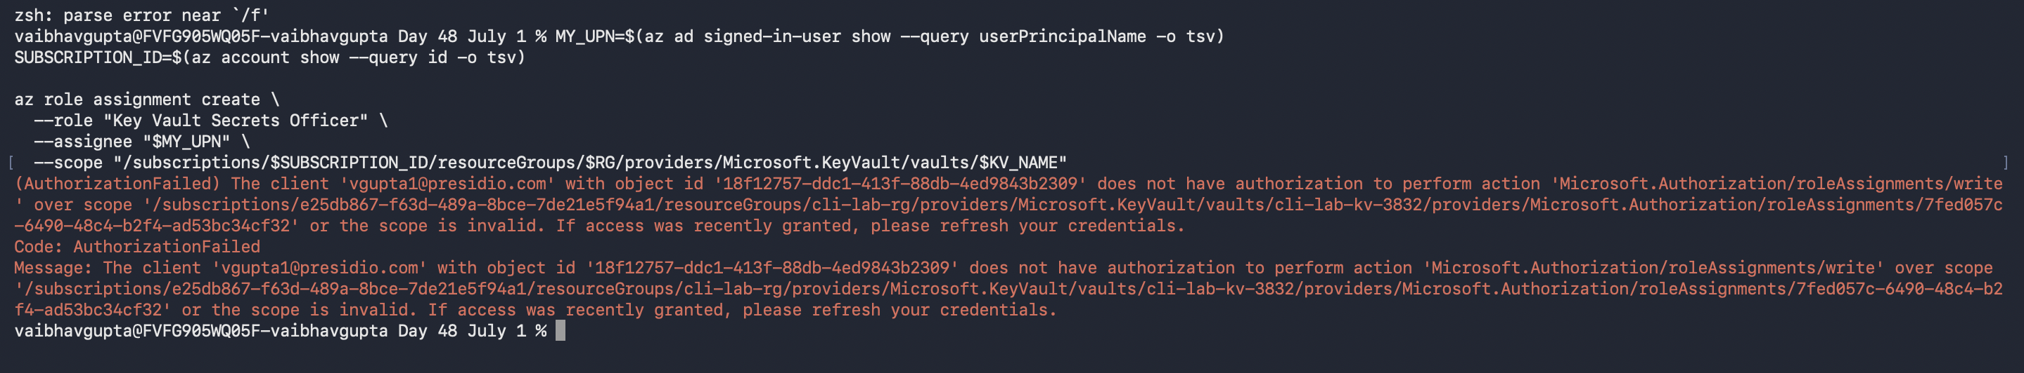

Step 3 — Smoke-Test the Vault
- Set a test secret and read it back:
az keyvault secret set --vault-name %KV_NAME% --name "HelloWorld" --value "it-works"
az keyvault secret show --vault-name %KV_NAME% --name "HelloWorld" --query value -o tsv
The second command should print: it-works
- Delete the test secret:
az keyvault secret delete --vault-name %KV_NAME% --name "HelloWorld"

RBAC issue, no permissions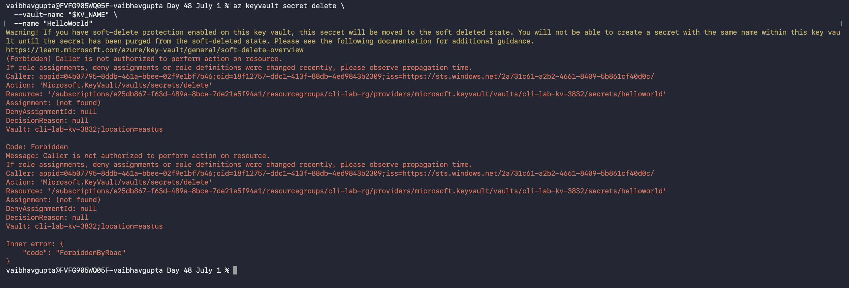

Lab 3: Blob Storage and the Connection String Secret

Step 1 — Create the Storage Account and Container
az storage account create ^
--name %SA_NAME% ^
--resource-group %RG% ^
--location %LOCATION% ^
--sku Standard_LRS ^
--kind StorageV2

az storage container create ^
--name %CONTAINER_NAME% ^
--account-name %SA_NAME% ^
--auth-mode login

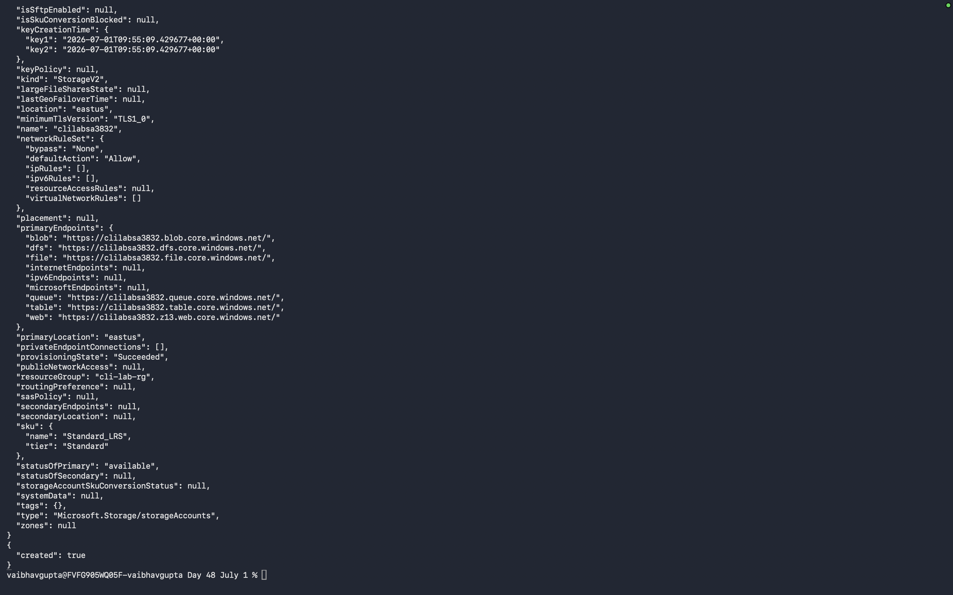

Step 2 — Capture the Connection String
for /f "delims=" %a in ('az storage account show-connection-string --name %SA_NAME% --resource-group %RG% --query connectionString -o tsv') do set CONN_STRING=%a
Tip
Verify the variable was captured: echo %CONN_STRING% — it should start with DefaultEndpointsProtocol=https

Step 3 — Store the Connection String in Key Vault
az keyvault secret set ^
--vault-name %KV_NAME% ^
--name "BlobStorageConnectionString" ^
--value "%CONN_STRING%"

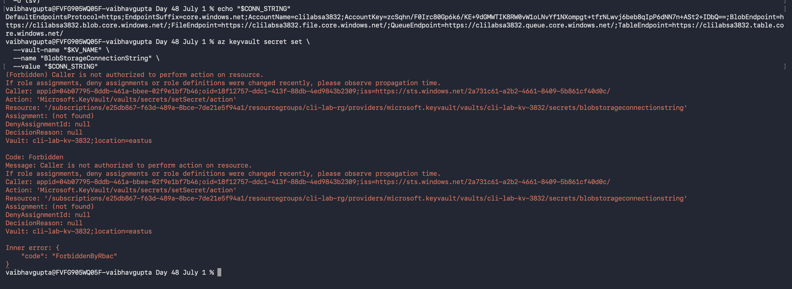
Permission issue

Important
This is the last time the connection string will be handled directly. From here on, only Key Vault knows it.

Lab 4: Scaffold the .NET Web API

Step 1 — Create the Project
Tip
Choose a folder on your machine where you want to create the project, then cd into it before running these commands.
dotnet new webapi -n BlobVaultApi --use-controllers
cd BlobVaultApi

Step 2 — Add the Azure NuGet Packages
dotnet add package Azure.Identity
dotnet add package Azure.Extensions.AspNetCore.Configuration.Secrets
dotnet add package Azure.Storage.Blobs

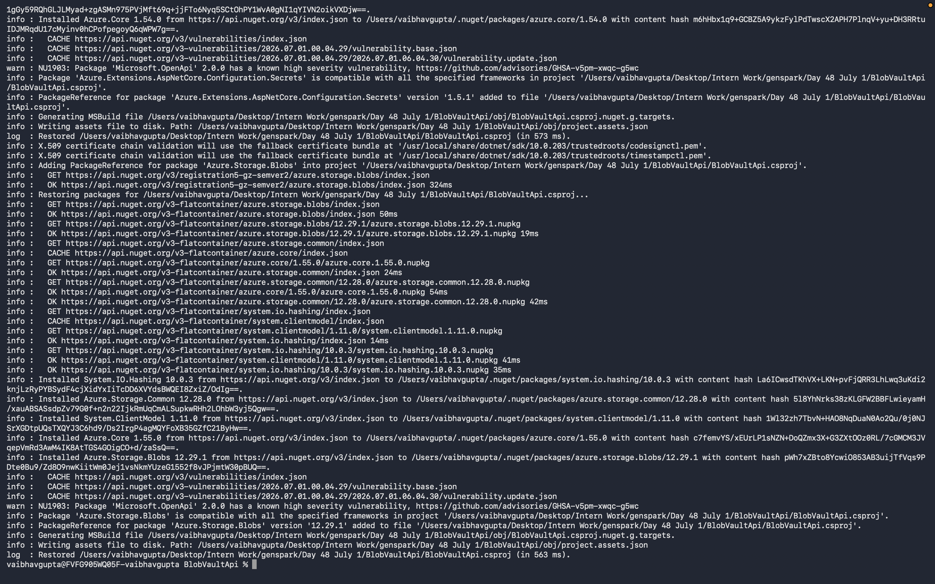

Package | Purpose
Azure.Identity | DefaultAzureCredential — uses your az login locally, Managed Identity in Azure
Azure.Extensions.AspNetCore.Configuration.Secrets | Maps Key Vault secrets directly into ASP.NET Core configuration
Azure.Storage.Blobs | Blob Storage client for upload and download

Lab 5: Wire Up Key Vault in Program.cs

Step 1 — Edit Program.cs
- Open BlobVaultApi/Program.cs in a text editor or IDE.
- Replace the entire file content with the following:
using Azure.Identity;

var builder = WebApplication.CreateBuilder(args);

var keyVaultUri = new Uri($"https://{builder.Configuration["KeyVaultName"]}.vault.azure.net/");
builder.Configuration.AddAzureKeyVault(keyVaultUri, new DefaultAzureCredential());

builder.Services.AddControllers();
builder.Services.AddEndpointsApiExplorer();
builder.Services.AddSwaggerGen();

var app = builder.Build();
app.UseSwagger();
app.UseSwaggerUI();
app.UseAuthorization();
app.MapControllers();
app.Run();

Step 2 — Set the Vault Name in App Settings
- Open BlobVaultApi/appsettings.Development.json and replace the KeyVaultName value with YOUR vault name (the value you wrote down from Lab 1):
{
"KeyVaultName": "YOUR-KV-NAME-HERE",
"Logging": { "LogLevel": { "Default": "Information" } }
}
Important
Replace YOUR-KV-NAME-HERE with the actual value from your KV_NAME fill-in box on page 2. Using the wrong name will cause a connection error when you run the app.

Step 3 — Verify the App Starts
dotnet run
Watch the startup log. You should see no errors. The app will print a localhost URL — leave it running.

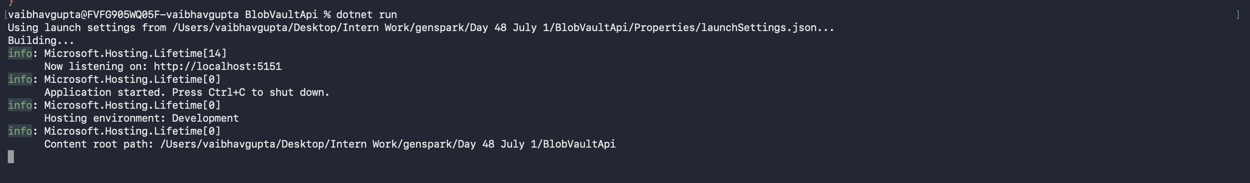

Lab 6: Blob Upload and Download Endpoints

Step 1 — Register the Blob Service Client
- Add the following to Program.cs, after the AddAzureKeyVault line and before builder.Build():
using Azure.Storage.Blobs;

builder.Services.AddSingleton(x =>
{
var connStr = builder.Configuration["BlobStorageConnectionString"];
return new BlobServiceClient(connStr);
});

Step 2 — Create the Files Controller
- Create a new file: BlobVaultApi/Controllers/FilesController.cs
- Paste in the following code:
using Microsoft.AspNetCore.Mvc;
using Azure.Storage.Blobs;

namespace BlobVaultApi.Controllers;

[ApiController]
[Route("api/[controller]")]
public class FilesController : ControllerBase
{
private readonly BlobContainerClient _container;
private const string ContainerName = "uploads";

public FilesController(BlobServiceClient blobServiceClient)
{
_container = blobServiceClient.GetBlobContainerClient(ContainerName);
_container.CreateIfNotExists();
}

[HttpPost("upload")]
public async Task<IActionResult> Upload(IFormFile file)
{
if (file is null || file.Length == 0)
return BadRequest("No file provided.");

var blobClient = _container.GetBlobClient(file.FileName);
using var stream = file.OpenReadStream();
await blobClient.UploadAsync(stream, overwrite: true);

return Ok(new { fileName = file.FileName, url = blobClient.Uri.ToString() });
}

[HttpGet("download/{fileName}")]
public async Task<IActionResult> Download(string fileName)
{
var blobClient = _container.GetBlobClient(fileName);
if (!await blobClient.ExistsAsync())
return NotFound();

var download = await blobClient.DownloadContentAsync();
return File(download.Value.Content.ToArray(), "application/octet-stream", fileName);
}
}

Step 3 — Run and Test
- Start the app:
dotnet run
- Open a SECOND cmd.exe window (leave dotnet run running in the first). Test the upload endpoint — replace sample.jpg with any image or file you have:
curl -F "file=@sample.jpg" https://localhost:5001/api/files/upload -k
- Test the download endpoint:
curl https://localhost:5001/api/files/download/sample.jpg -k -o downloaded.jpg

Lab 7: Deploy with a Managed Identity

Step 1 — Create the App Service Plan and Web App
set APP_NAME=cli-lab-api-%SUFFIX%

az appservice plan create ^
--name cli-lab-plan ^
--resource-group %RG% ^
--sku B1 ^
--is-linux

az webapp create ^
--name %APP_NAME% ^
--resource-group %RG% ^
--plan cli-lab-plan ^
--runtime "DOTNETCORE:8.0"

📷 Screenshot
az webapp create output — JSON showing the web app hostname (e.g. cli-lab-api-XXXXX.azurewebsites.net)
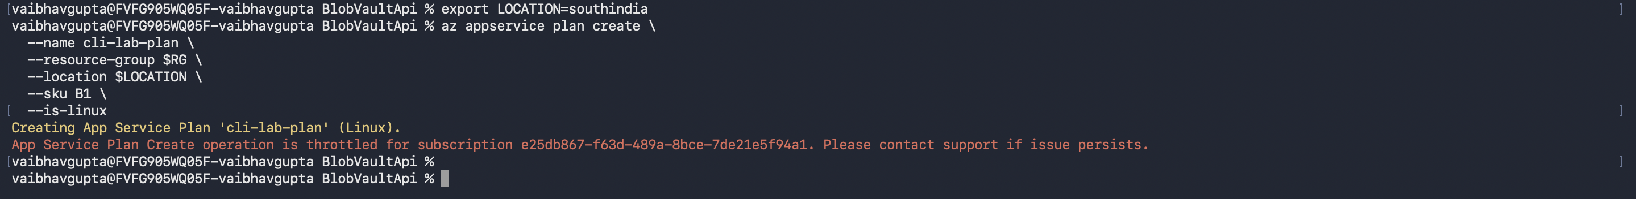
Prevented

APP_NAME value | _______________________________________________

Step 2 — Configure the App Setting
az webapp config appsettings set ^
--name %APP_NAME% ^
--resource-group %RG% ^
--settings KeyVaultName=%KV_NAME%

Step 3 — Assign a Managed Identity
az webapp identity assign --name %APP_NAME% --resource-group %RG%
- Capture the identity's principal ID:
for /f "delims=" %a in ('az webapp identity show --name %APP_NAME% --resource-group %RG% --query principalId -o tsv') do set PRINCIPAL_ID=%a

📷 Screenshot
az webapp identity assign output — JSON showing the principalId and tenantId

Step 4 — Grant the Identity Key Vault Access
az role assignment create ^
--role "Key Vault Secrets User" ^
--assignee %PRINCIPAL_ID% ^
--scope "/subscriptions/%SUBSCRIPTION_ID%/resourceGroups/%RG%/providers/Microsoft.KeyVault/vaults/%KV_NAME%"

Step 5 — Publish and Deploy
cmd.exe has no built-in zip command, so you will call PowerShell just for the compression step:
dotnet publish -c Release -o .\publish
cd publish
powershell -Command "Compress-Archive -Path * -DestinationPath ..\publish.zip -Force"
cd ..

az webapp deploy ^
--name %APP_NAME% ^
--resource-group %RG% ^
--src-path publish.zip ^
--type zip

📷 Screenshot
az webapp deploy output confirming successful zip deployment

Step 6 — Test in the Cloud
curl -F "file=@sample.jpg" https://%APP_NAME%.azurewebsites.net/api/files/upload

📷 Screenshot
Successful cloud upload — curl output showing the blob URL on azurewebsites.net

Lab 8: Cleanup
Important
This step permanently deletes all resources created today. Only run it when you are completely finished with the lab.
az group delete --name %RG% --yes --no-wait

📷 Screenshot
az group delete running — terminal confirming the delete command was accepted

Reflection Questions
Answer the following questions to check your understanding of the lab.

1. Why is the Blob Storage connection string stored in Key Vault instead of in appsettings.json?
Key Vault keeps the connection string secure. It avoids storing sensitive information directly in the application files
2. What is DefaultAzureCredential, and why does the same line of code work both locally and in Azure?
DefaultAzureCredential automatically uses your Azure login on your computer and Managed Identity in Azure. So the same code works in both places.
3. Why does the App Service identity get the Key Vault Secrets User role instead of Secrets Officer?
The Secrets User role only allows reading secrets. It is safer because the app does not need permission to create or delete secrets.
4. What would happen if you accidentally committed appsettings.json with the raw connection string to a public GitHub repository? How does this lab's approach prevent that?
The Secrets User role only allows reading secrets. It is safer because the app does not need permission to create or delete secrets.

Common Errors
Error | Fix
InvalidResourceGroup: name has invalid character '$' | You are using PowerShell/bash variable syntax. Switch to cmd.exe and use %VAR% syntax
No such host known (vault.azure.net) | The vault name in appsettings.Development.json is still the placeholder. Replace it with your actual KV_NAME value
403 Forbidden (Key Vault) | Role assignment hasn't propagated yet — wait 60 seconds and retry
DefaultAzureCredential fails | Run az login again in the same cmd.exe window
curl upload returns 401/403 | The App Service Managed Identity role assignment may not have propagated — wait 2 minutes

